For more information: didavmitchell@gmail.com or monica.hanaway@ntlworld.com

M&D ASSOCIATES
2018
Offer two Guernsey based courses
MEDIATION: START to FINISH
This one-day interactive course is for people wanting to know what mediation and for trained mediators
We will provide this unique CPD opportunity to see the mediation process and to develop skills in ‘tuning in’ (the early phase of the process aimed at understanding the issues, values and behaviours of the parties) through to the ‘tuning out’ stage (including the drawing up of the agreement)
Date: 24thMarch 2018

CO-MEDIATION
Those interested in also developing their co-mediation skills may also be interested in the one-day Co-Mediation course, which will run the following day –
Sunday 25th March 2018
Venue for both days: Bella Luce, Guernsey
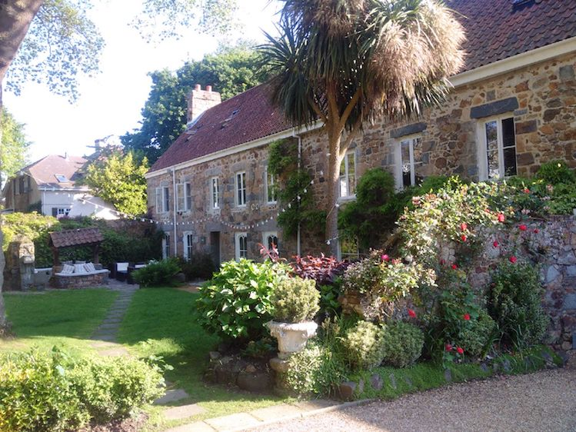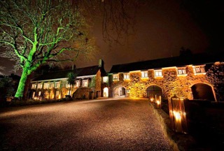

Fees: £250 per day or £450 if booking for both days
Early bird Fees: £225 per day or £400 if booking for both days before 1st February 2018

monica.hanaway@ntlworld.com
didavmitchell@gmail.com

